**AWS Code Build**

**AWS CodeBuild is a fully managed build service in the cloud. CodeBuild compiles your source code, runs unit tests, and produces artifacts that are ready to deploy. CodeBuild eliminates the need to provision, manage, and scale your own build servers. It provides prepackaged build environments for popular programming languages and build tools such as Apache Maven, Gradle, and more. You can also customize build environments in CodeBuild to use your own build tools. CodeBuild scales automatically to meet peak build requests.**

**#firstly you have an code project file with buildspec.yaml file on your github repository**

[**https://github.com/vishwanathacharya/cicd-codebuild1**](https://github.com/vishwanathacharya/cicd-codebuild1)

**#Create S3 Bucket for Your Source Code**

**Create Two Bucket**

**1. Artifacts**

**2. Destination Sources**

**Open Amazon Services**

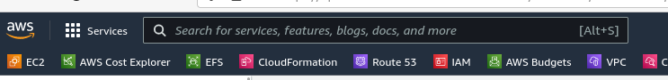

**& Search S3 Service**

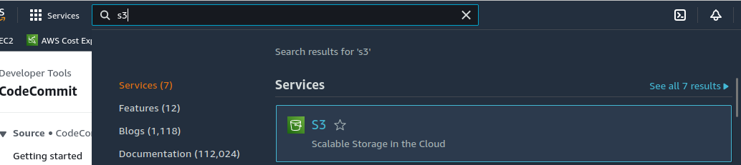

**Open it**

**Create Bucket**

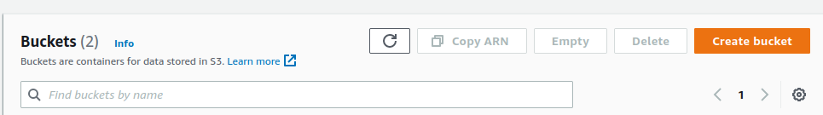

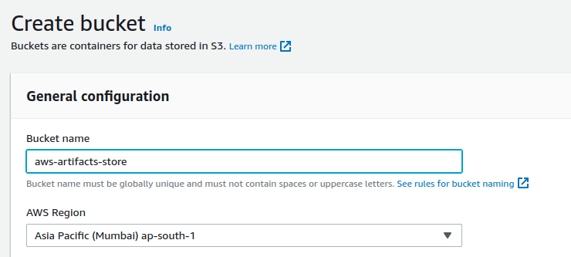

**Bucket Name AWS-artifacts-Store**

**This BUCKET Store Source Code Artifacts Before Build & Post Build Files in Zip Format**

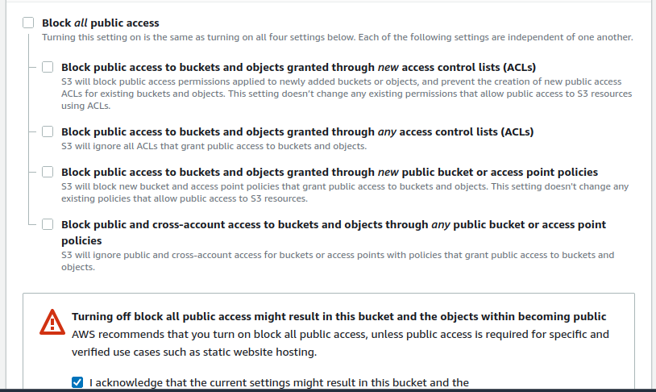

**Enable Bucket Versioning**

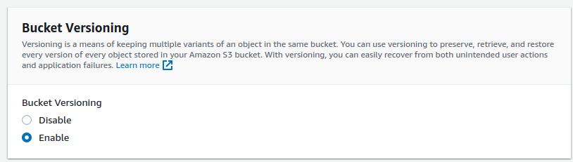

**Create Bucket**

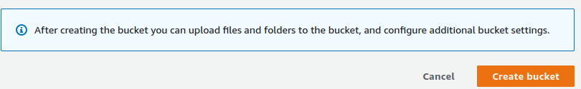

**Create Another Destination Bucket for Using For Deploy**

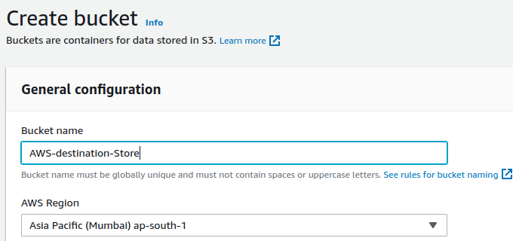

**Create Bucket AWS-destination-store**

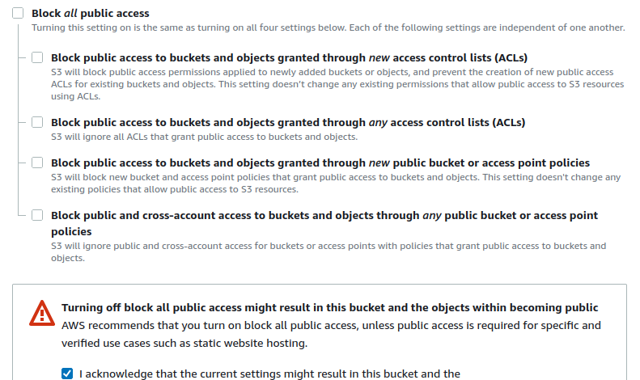

**Enable Versioning**

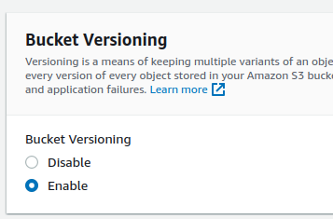

**Create Bucket**

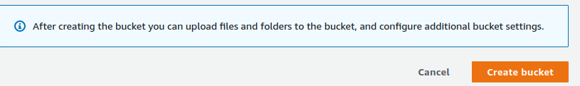

**Open Destination Store for Enable Static Web Site**



**Open Properties**

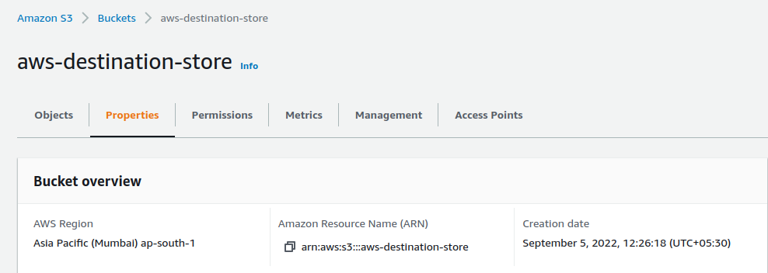

**Enable Static hosted Website** 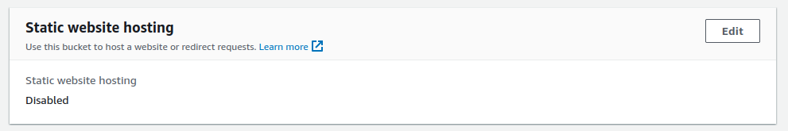

**Click On Edit**

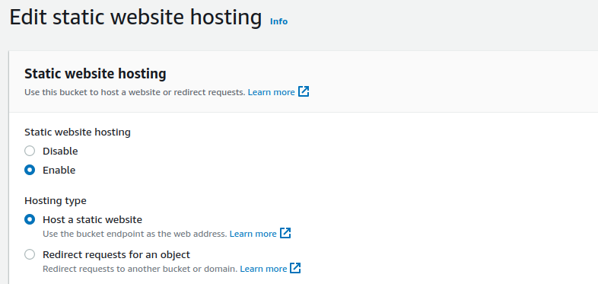

**Add Index document**

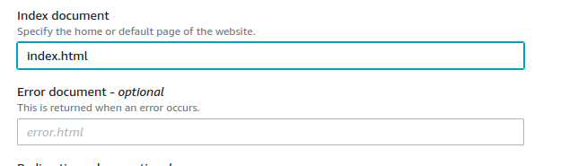

**Save Change**



**Search AWS Code Build on Your AWS Management Console**

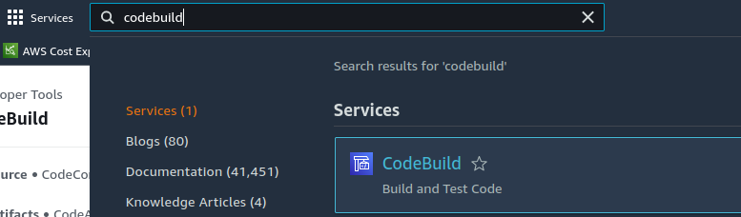

**Open CodeBuild**

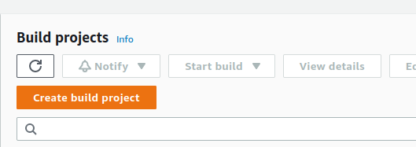

**Create Build Project**

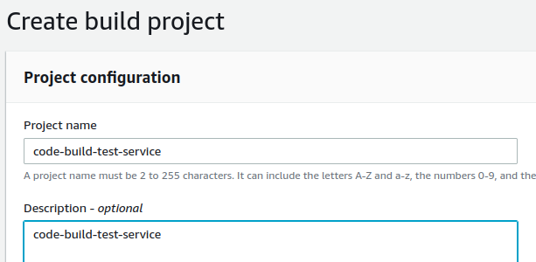

**Add Source Code Provider**

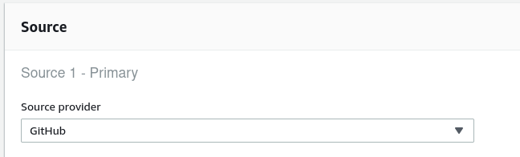

**Add Your Repository**

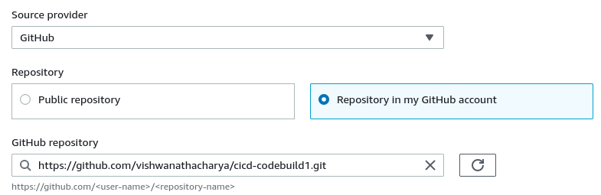

**Set up Environment**

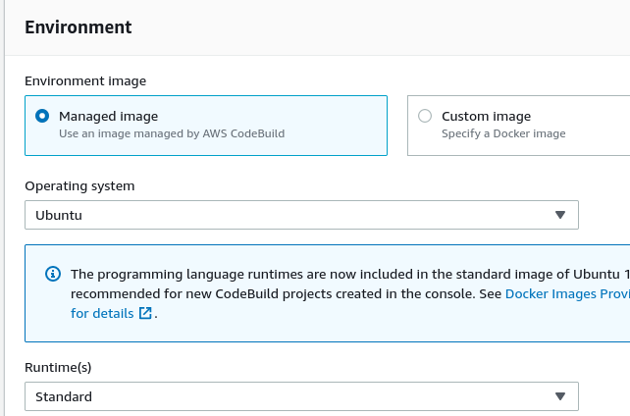

**Choose Latest Image**

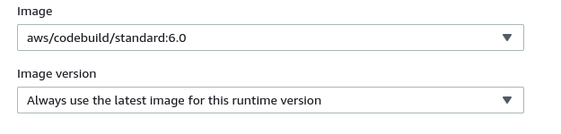

**Add new Service Role**

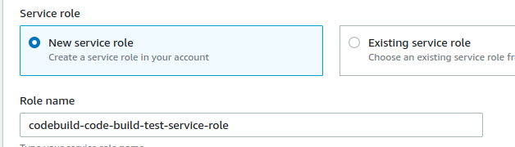

**Create Build Project**



**Show this Error**

**A policy called CodeBuildBasePolicy-code-build-test-ap-south-1 already exists. Duplicate names are not allowed.**

**So delete this policy**

**Search Code Pipeline In AWS management Console**

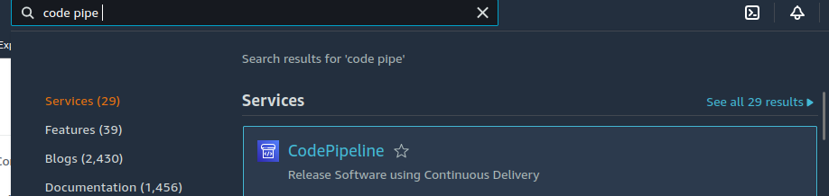

**Open It**

**Create Pipe Line**



**Add Pipeline Name**

**Service Role**

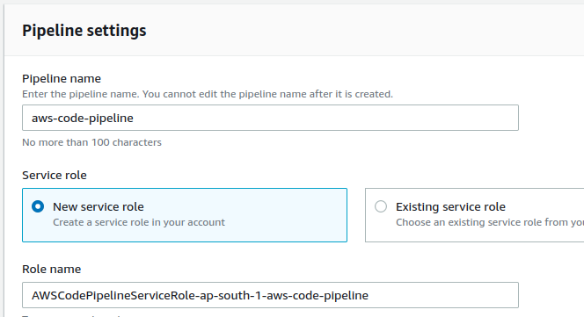

**Use Your Custom s3 Bucket Artifacts**

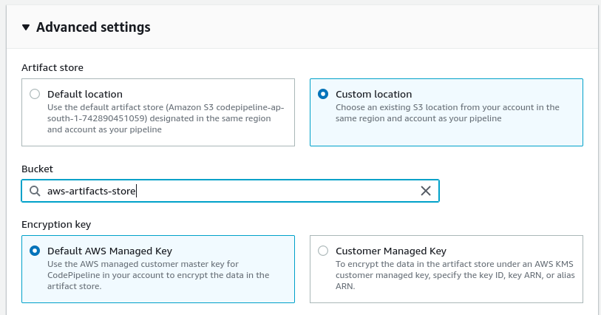

**Add source stage**

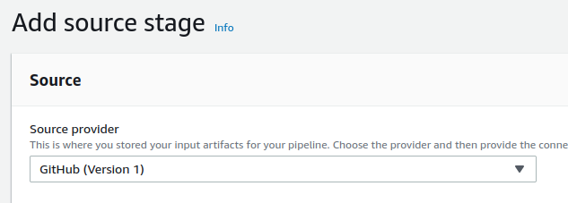

**Next Choose your Repo & Branch**

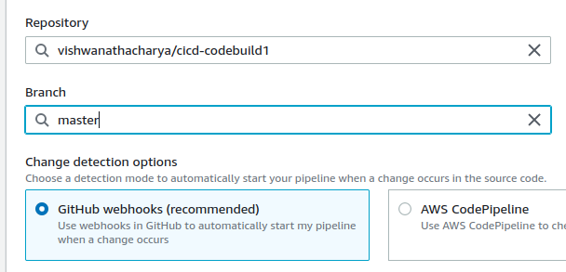

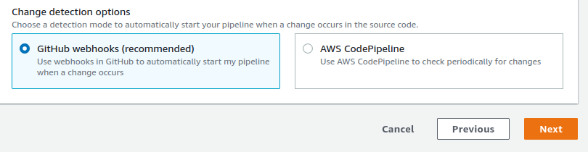

**Next**

**Add Build Stage**

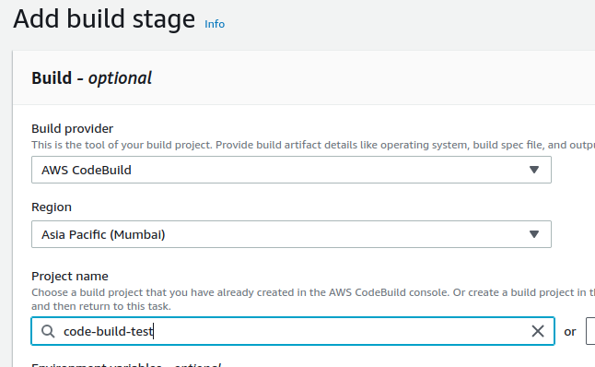

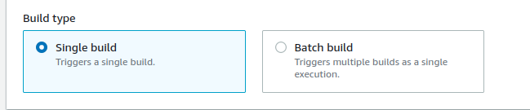

**Add Deploy Stage**

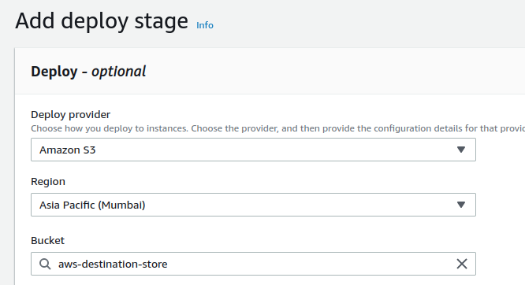

**Choose Destination Bucket**

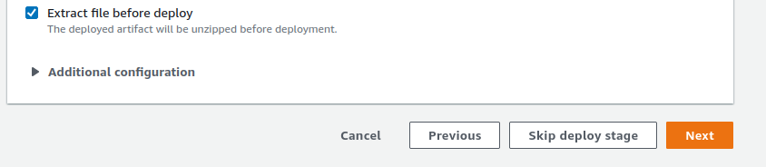

**Extract File Before Deploy**



**aws -code-pipeline**

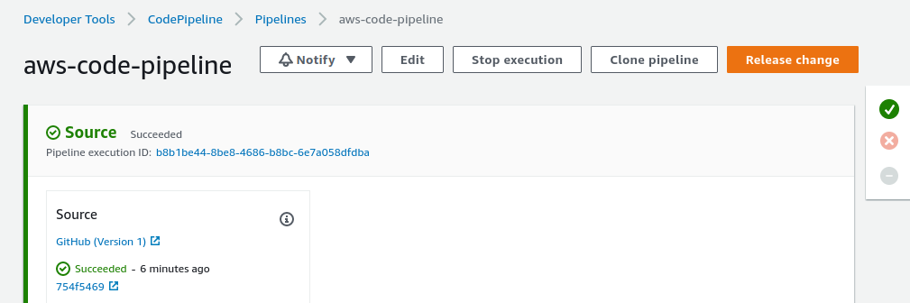

**Code Build Failed Beacuse Not attached S3 Full Access**

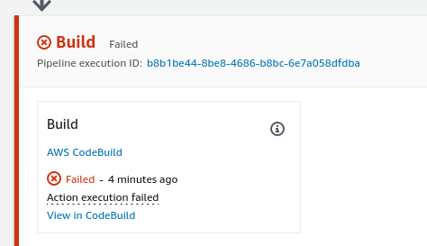

**Go To Code Build**

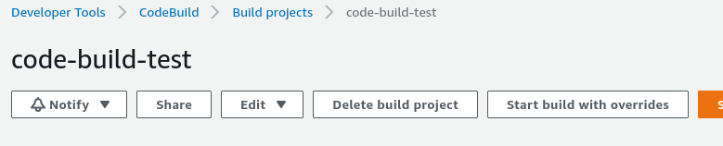

**Open Failed build AAND View Log**

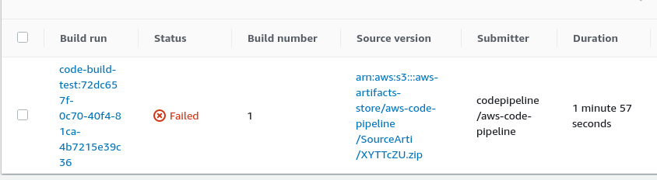

**Logs Show to Error where occur**

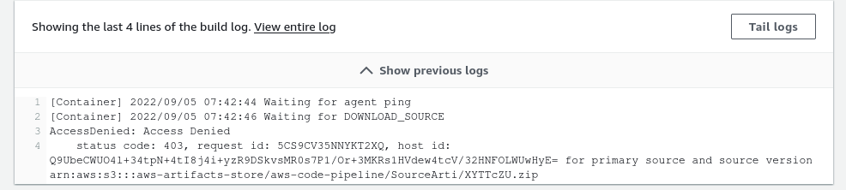

**Go to Build Details**



**Open Service Role**

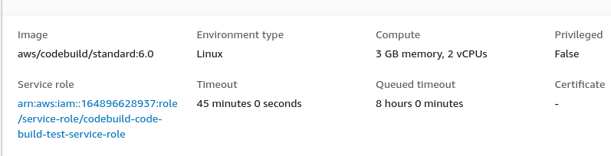

**Open Images Service Role**

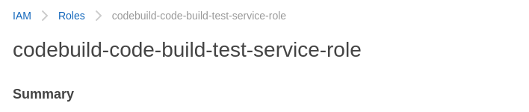

**Add Permision AWSS3FullAccess**

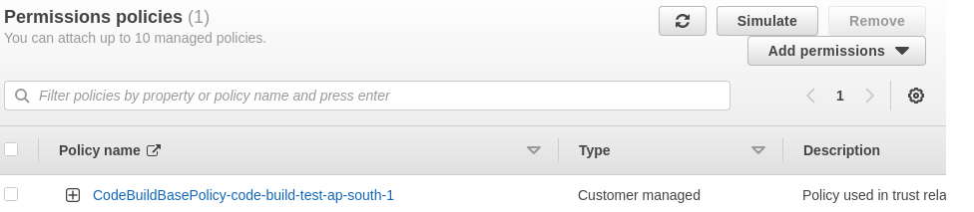

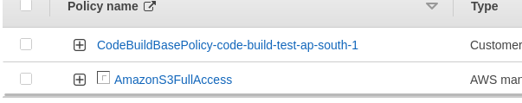

**Retry Code Build**

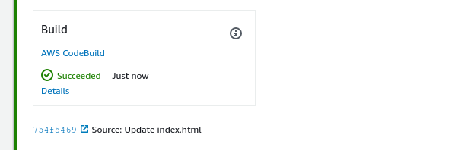

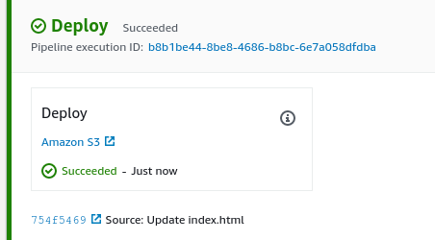

**Go to S3 Bucket**

**Artifact Bucket Here Present TWO object**

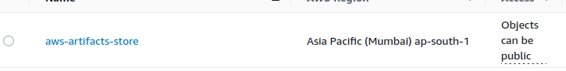

**Open Artifact store**



**Open it pipeline**

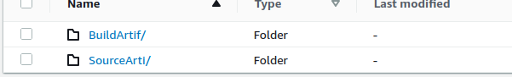

**Here two object present in bucket**

**SourceArtif is Source Code from Pull from Github repository**

**BuildArtif is Build After CodeBuild**

**Both of file is Zip file**

**Open Destination Bucket**

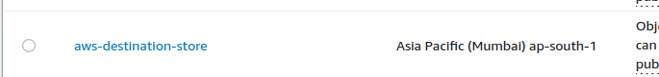

**Open it**

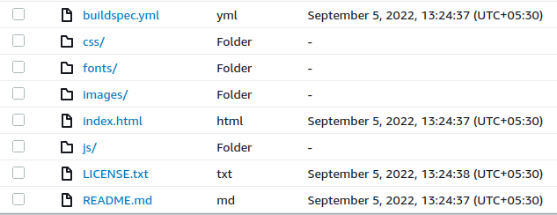

**Go To Properties**

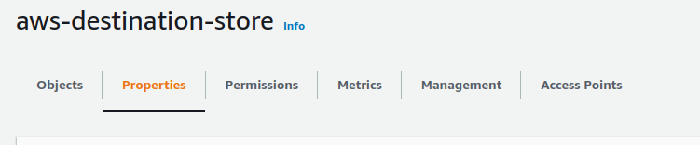

**Copy URL**

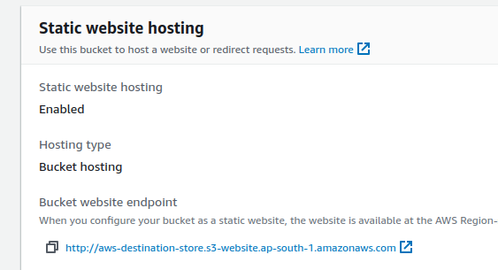

**Paste It google check it**

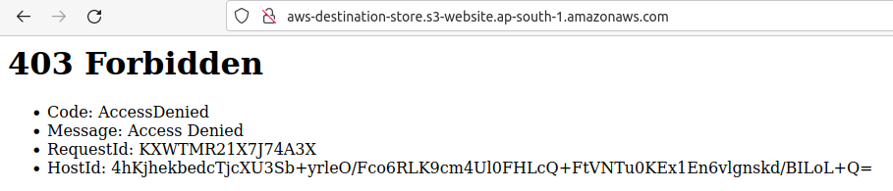

## **Granting read-only permission to an anonymous user**

<https://docs.aws.amazon.com/AmazonS3/latest/userguide/example-bucket-policies.html>

{

"Version": "2012-10-17",

"Statement": [

{

"Sid": "PublicRead",

"Effect": "Allow",

"Principal": "*",

"Action": [

"s3:GetObject",

"s3:GetObjectVersion"

],

"Resource": [

"arn:aws:s3:::DOC-EXAMPLE-BUCKET/*"

]

}

]

}

Come To Server Access Login

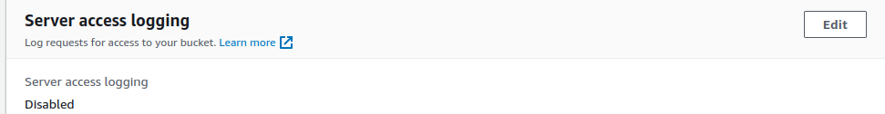

**EDIT**

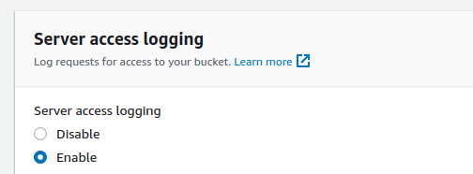

**Choose Target Bucket**

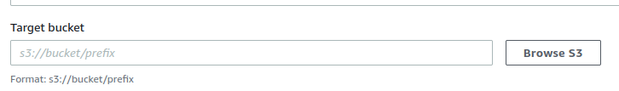

**Choose Destination Bucket**

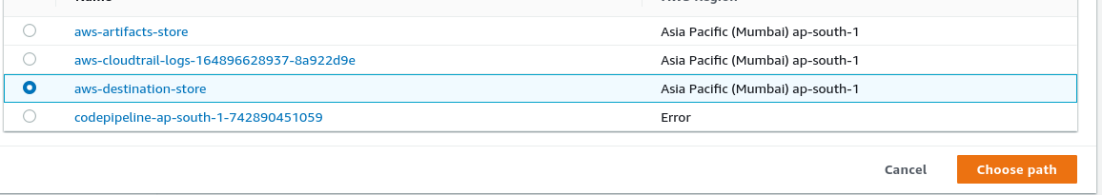

**Save Cahnges**

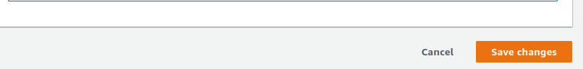

**Come into Permission**

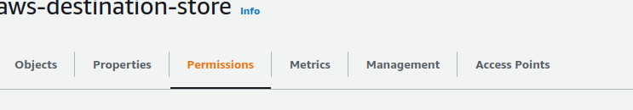

**Edit Bucket Policy**

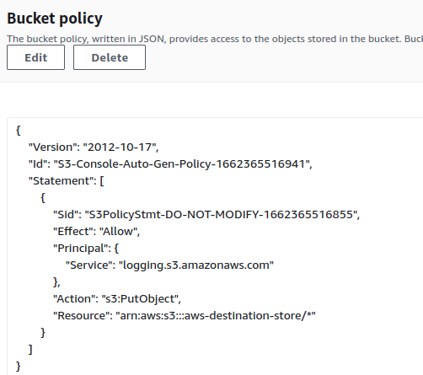

**Copy & Paste the policy**

**Edit and paste it with YOUR Bucket name**

**{**

**"Version": "2012-10-17",**

**"Statement": [**

**{**

**"Sid": "PublicRead",**

**"Effect": "Allow",**

**"Principal": "*",**

**"Action": [**

**"s3:GetObject",**

**"s3:GetObjectVersion"**

**],**

**"Resource": [**

**"arn:aws:s3:::aws-destination-store/*"**

**]**

**}**

**]**

**}**

**Permission Public For Read and Write**

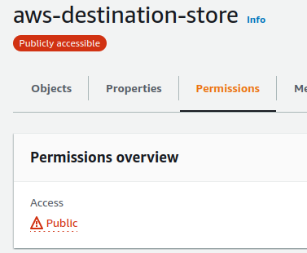

**Copy Object Properties URL & PASTE IT BROWSER**

